East Missoula Highway 200 Corridor Plan
Update January 2020

The Missoula Metropolitan Planning Organization has begun the process for a Corridor Plan on Highway 200 from Van Buren Street to Tamarack Road. The Corridor Plan will address Highway 200 east of Missoula in three segments: East Missoula Segment (from I-90 to Brickyard Hill), Western Segment (from Van Buren Street to I-90, and Eastern Segment (from Brickyard Hill to Tamarack Road).

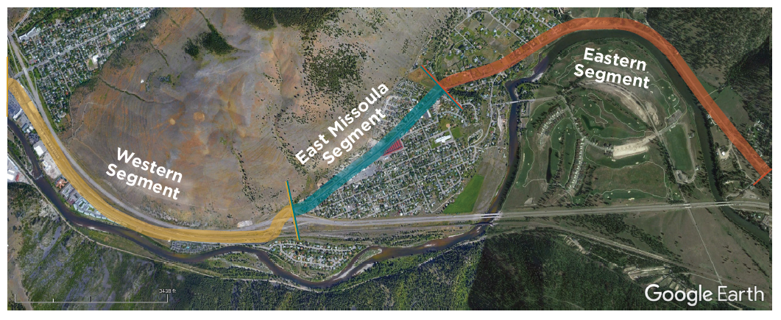

What is a Highway Corridor Plan?

Highway corridor planning is the coordination of transportation and land use activity along the highway. Land uses and transportation are interconnected – where each is placed and designed can positively or negatively affect the other. Transportation corridor planning, including highway corridor plans, intend to improve safety and create better connections among motorized and non-motorized transportation and land uses. Corridor plans provide an overall vision to guide decisions on infrastructure and land use by state departments of transportation, local governments, landowners, developers and residents. Corridor plans identify improvements needed for safety of motorists and non-motorists, with consideration for transport of water, sewer, power, telecommunications, as well as environmental concerns.

Why prepare a plan now for the East Missoula Highway 200 Corridor?

The portion of Highway 200 from Van Buren Street to Tamarack Road has significant barriers for the community due to uncontrolled access and other safety concerns. The lack of designated or controlled driveways, non-motorized facilities, and other safety-related infrastructure has led to conflicts between vehicles, pedestrians, and cyclists travelling throughout the area. Through the preparation of this plan, alongside the achievement of transportation and safety goals, we hope to progress long-discussed community goals of reshaping the corridor and preparing for future commercial and residential development along Highway 200. Previous work in this area has been primarily focused on East Missoula with traffic studies, safety assessments and the 2015 report, East Missoula Corridor Vision and Redevelopment. Until now there has been no comprehensive approach nor strategic plan for implementing change.

Who is developing the East Missoula Highway 200 Corridor Plan?

The Missoula Metropolitan Planning Organization (MMPO) is leading the effort with the assistance of WGM Group, Inc. The MMPO is a regional transportation planning body for the federally designated Metropolitan Planning Area that includes the City of Missoula and adjacent urban areas in Missoula County. WGM Group, Inc. is a Missoula-based engineering and design firm.

How will the public be involved in developing the plan?

Public outreach and involvement includes:

- Project website: https://www.missoulampo.com/east-missoula-highway-200-corridor-
Periodic updates, portal for project documents, and an interactive map where you can post site-specific comments
- Three public open houses. Exact dates and locations will be posted on the project website.
  - Open House #1: Feb 6, 5:30-7:30 p.m., East Missoula Fire Hall
  - Open House #2: June
  - Open House #3: September
- Stakeholder Meetings
- Advisory Committee: An Advisory Committee has been established to provide guidance on this project. Members represent local and state government transportation and planning, East Missoula Community Council, economic development, bike/ped, transit, trails, parks, and recreation.

Schedule and Process for the Plan

Fall 2019 | Introductory Framework Report - Summarizing previous studies and identifying needed information  Begin Technical Analysis
Jan 2020 | Technical Analysis Report – Detailed Analysis of Needs
Feb 2020 | Open House #1 – Review findings and obtain comment
March - May 2020 | Draft Design Alternatives
June 2020 | Open House #2: Review alternatives and obtain comment
Sept 2020 | Preferred Alternative Report  Open House #3: Present Preferred Alternative and obtain comment
Nov 2020 | Draft Plan released for public comment
Jan 2021 | Plan Approval

Comments and Additional Information
Contact Anne Cossitt at acossitt@wgmgroup.com or at WGM Group, 1111 E. Broadway, Missoula, MT 59802, 406.422.6555 (cell).

